AI Assisted Coding

Lab Test – 04 Date: 12.11.2025 24BTCAICSB01 and 24BTCAICSB02

SET 1
Q1. Using AI tools, design a Hotel Reservation Database Schema.
- Create tables: Guests, Rooms, and Bookings.
- Insert Data in to these three tables
- Generate queries to find available rooms between given check-in and check-out dates.
Q2. Use AI to generate a Python script that removes outliers in a numeric dataset using Z-score and saves the cleaned data to a new CSV file. (First randomly generate some data to complete this task)
=================================================================================
SET 2
Q1. With AI assistance, create a Vehicle Service Management database.
- Include tables: Customers, Vehicles, Service_Records.
- Insert Data in to these three tables
- Write a query to find all vehicles serviced in the last 30 days.
Q2. Use AI to translate a JAVA array sorting program into Python, and verify that both outputs match for a given array.

SET 3
Q1. Generate with AI a University Examination Database schema.
- Tables: Students, Subjects, Marks.
- Insert Data in to these three tables
- Write SQL to find students scoring above 85% in all subjects.

Q2. Using AI, create a Python preprocessing script to:
- Generate some random text to complete below two tasks
- Remove special characters and numbers from a “review” column.
- Convert text to lowercase and remove stop words.

SET 4
Q1. Design a Hospital Billing Database using AI.
- Include tables: Patients, Services, Bills.
- Insert Data in to these three tables
- Write SQL queries to calculate the total bill for each patient using a JOIN.
Q2. Using AI-generated Python code, normalize numeric columns in a healthcare dataset using Min-Max scaling and handle missing data with column medians. (First randomly generate some healthcare dataset to complete this task)

SET 5
Q1. Generate AI-assisted SQL for a Retail Store Inventory system.
- Tables: Products, Categories, Sales.
- Insert Data in to these three tables
- Write SQL to calculate total sales per category.
Q2. Use AI to convert a Python list comprehension that filters even numbers into equivalent JavaScript code.
- Compare execution results and discuss differences in syntax and output.
SET 5:

Q1. Generate AI-assisted SQL for a Retail Store Inventory system.
- Tables: Products, Categories, Sales.
- Insert Data in to these three tables
- Write SQL to calculate total sales per category.
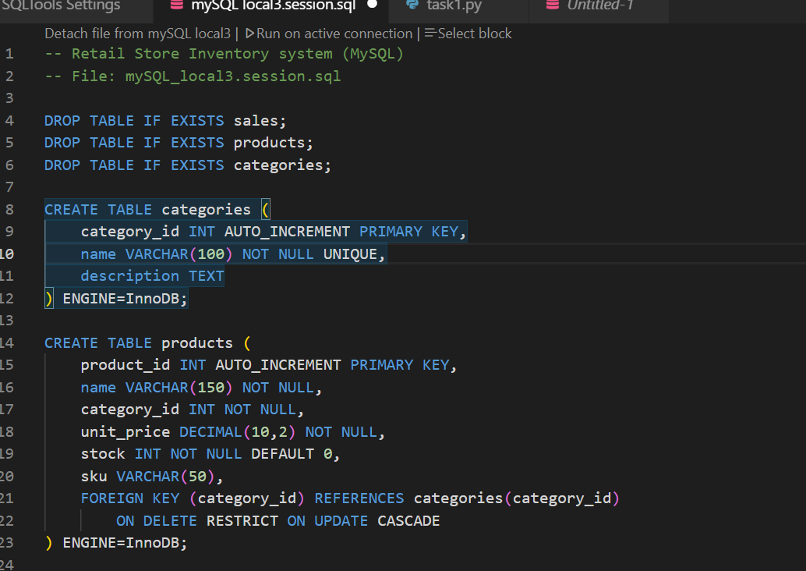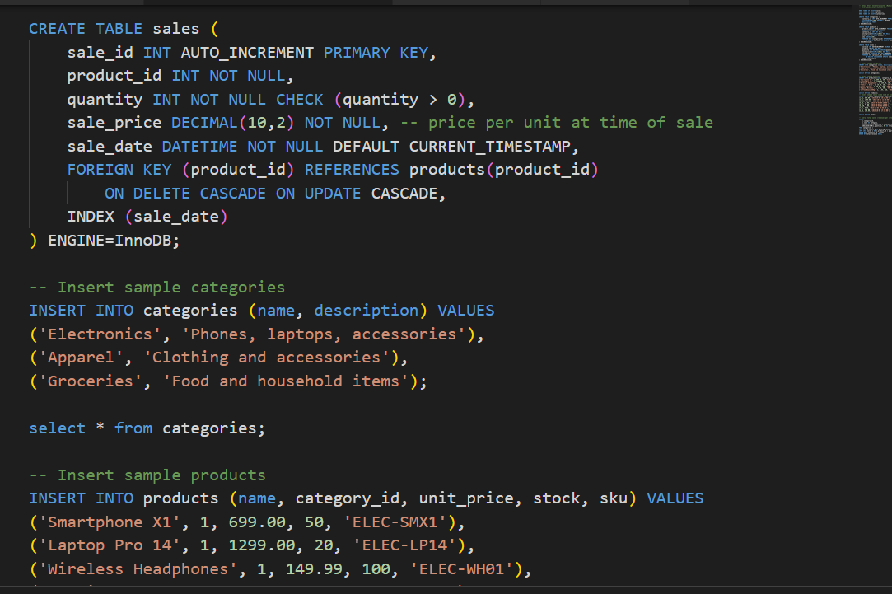

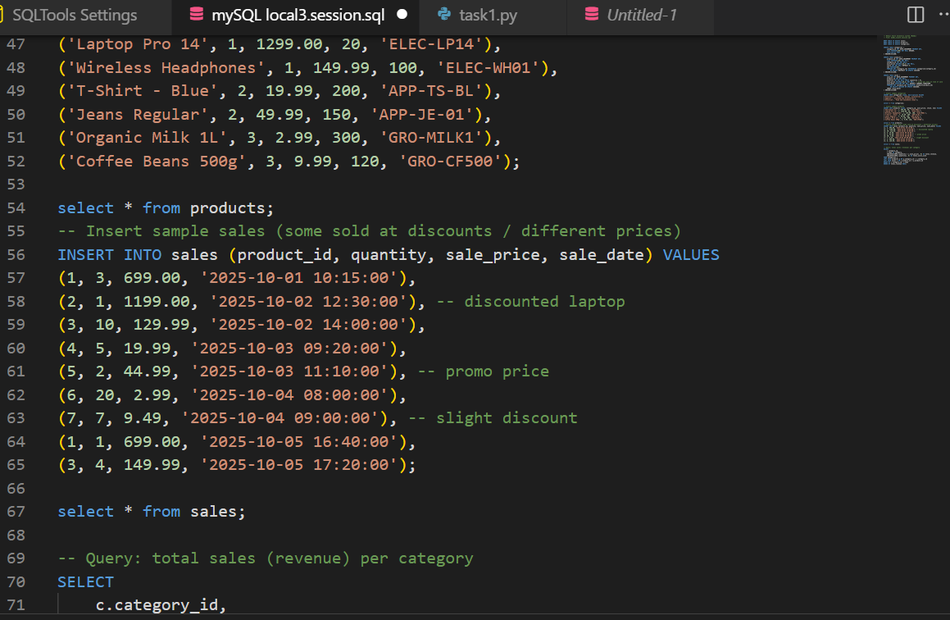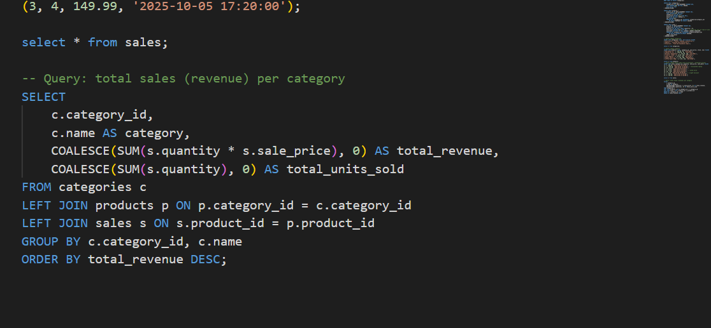
OUTPUT:
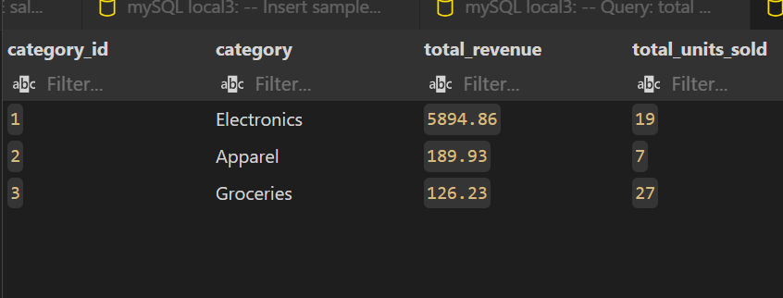

Q2. Use AI to convert a Python list comprehension that filters even numbers into equivalent JavaScript code.
- Compare execution results and discuss differences in syntax and output.
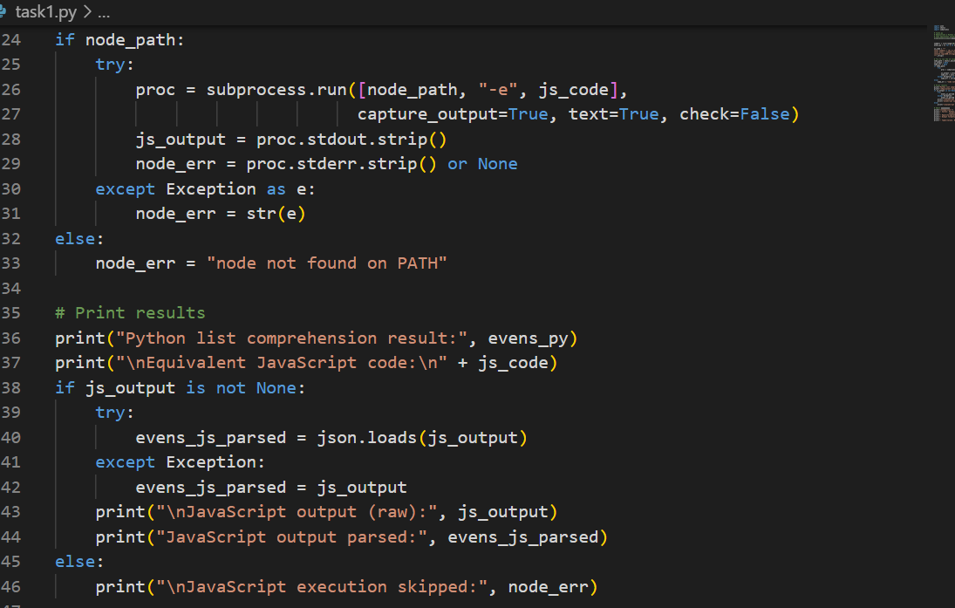
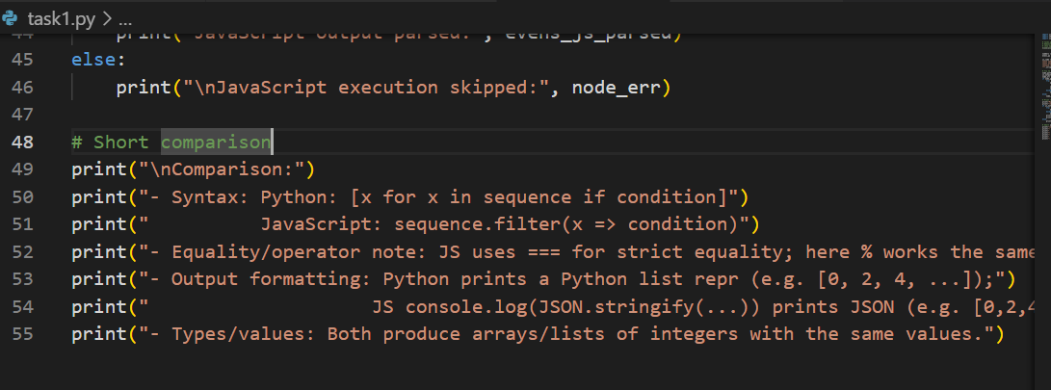
OUTPUT:
